Rachel Gully

CFRS 772 – Homework 11

April 15th, 2019

1. Result of running the Volatility “MyPlugin” against vm.vmem.

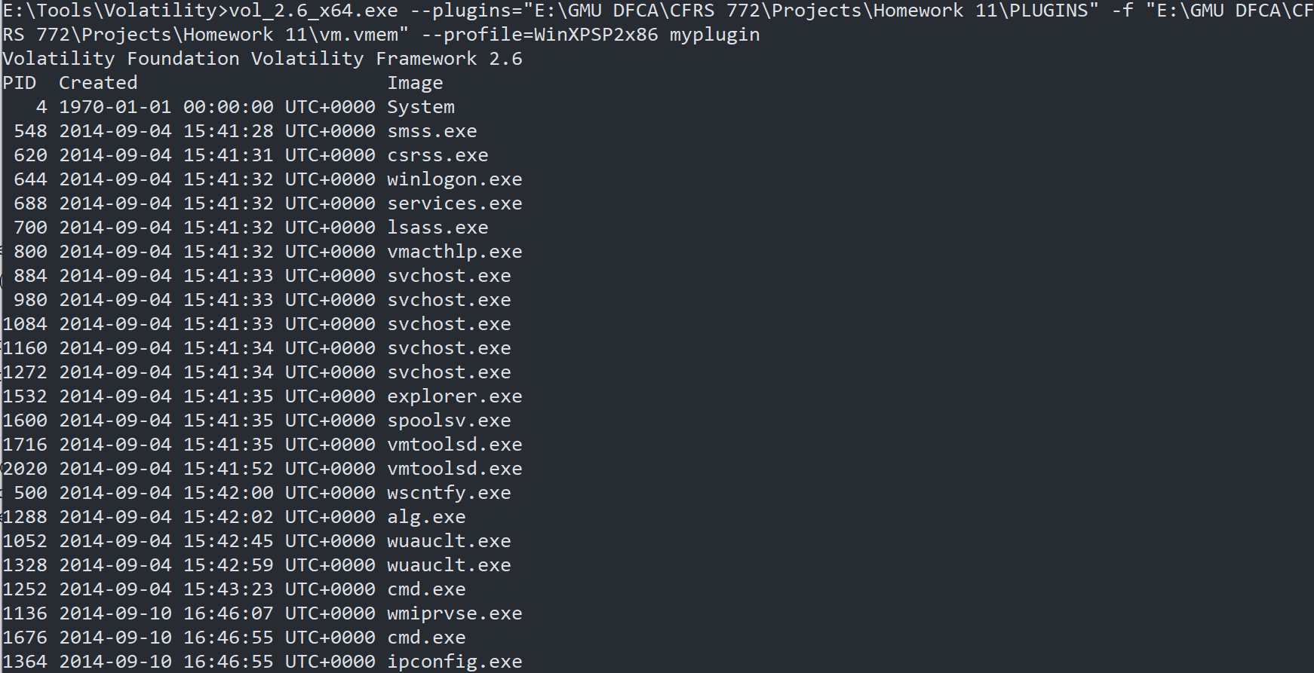

1. Listing of current Autopsy ingest modules, highlighting the “HW11” additions.

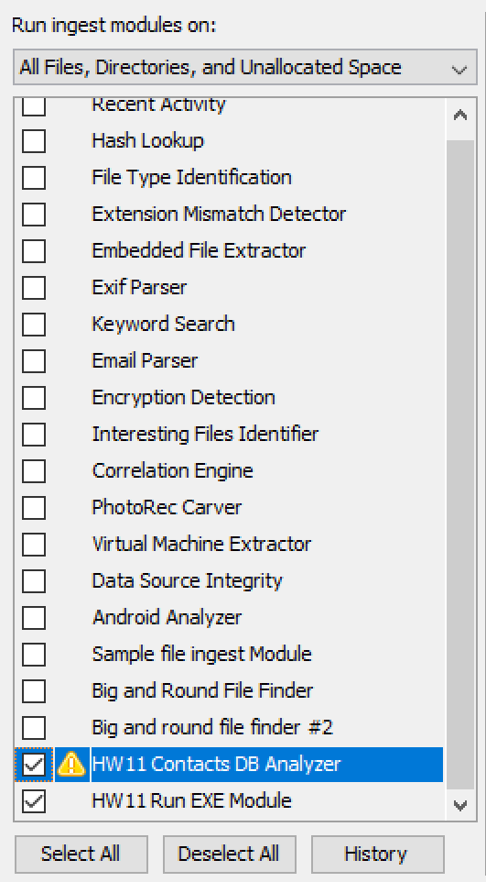

1. Result of running the Autopsy “HW11 Data Source Module” against contacts.db.

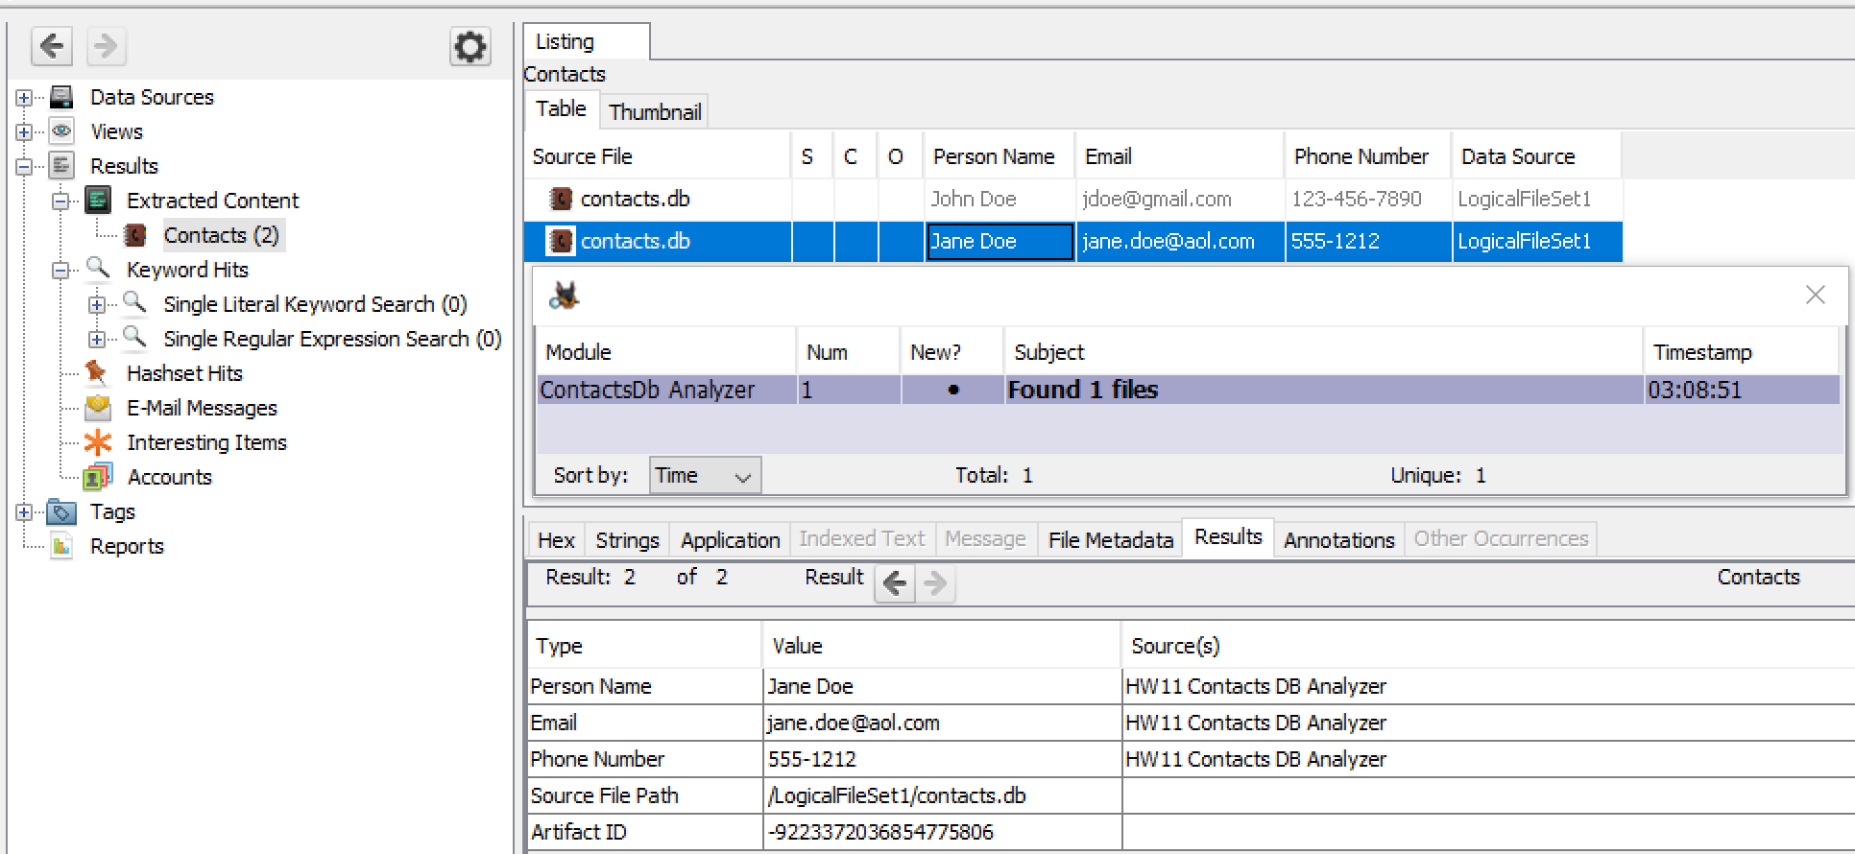

1. Result of running the Autopsy “Run Exe” Ingest Module against “control.dd” from <https://www.cfreds.nist.gov/Controlv1_0/DCFL_Control_Standard_V1_0.html>.

